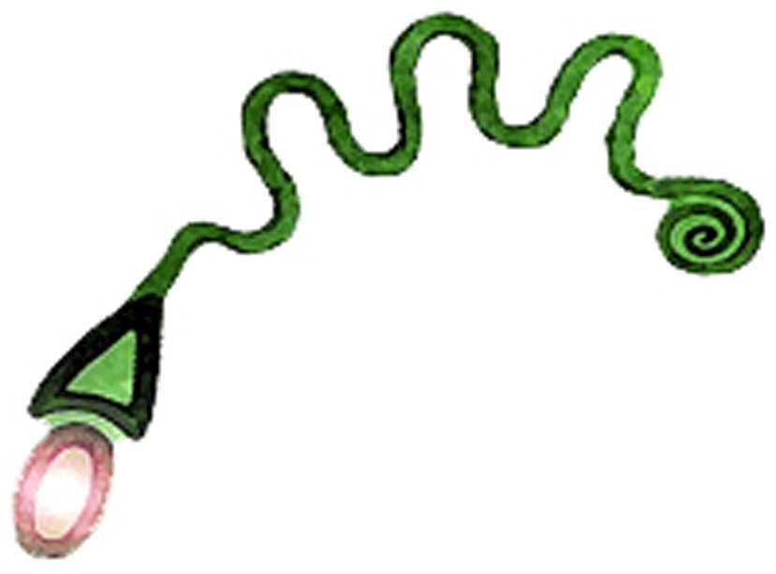
Friends of Serpent Mound Membership Form
Membership fee structure:

Family – Will cover two adults and children. ($10)

Individual – One person. ($5)

Membership Benefits:
- Special events
- Camping at the Summer Solstice Celebration
- Members can become Board Members
Please fill in the following form and mail to…
Friends of Serpent Mound, 148 Horner Chapel Rd, Peebles, OH 45660
Or email all of the below information to delseywilson@serpentmound.org, and visit our web site at www.serpentmound.org to pay your fee.

Name:

Street Address:

City: State: Zip:

Email Address:

Home Phone Number: ( ) -

Cell Phone Number: ( ) -

Would you prefer to receive email or text reminders?

Are you interested in Volunteering at Friends of Serpent Mound events? Yes No

Do you have a talent or hobby that you would like to use at an event? Yes No

If yes, what is it?

We have events with vendors. Would you like to be contacted as a possible vendor?
Yes No

Member Agreement

I would like a: Family Membership ($10) Individual Membership ($5)

As a member of FOSM, you are a supporter of the organization. You have voter rights at our meetings. However, all Official statements of FOSM comes directly from the FOSM Board and their representative, the Executive Director. In order to be asked to renew ones membership, one must remain in good standing with the Board, by following event rules and not speaking for the organization.

Event Rules:
- This is a family friendly event - there is to be NO alcohol, drugs, guns, or nudity!
- Children are welcome and must be supervised by a parent or guardian at all times.
- There is no smoking in the Main Tents or within the group hikes. There are proper places to put one’s cigarette butts, so please do not throw them on the ground.
- There is to be NO Indian Policing or Politics permitted – All Races, All Religions, All Our Relations
- Dogs are permitted, but must be leashed at all times, next to owner, and must be cleaned up after.
- The back gate to the Serpent Mound Park will close at dark, no one may re-enter until daylight.

The Purpose of FOSM: Protect, preserve, and promote Serpent Mound and other Native American sites, while facilitating education and experiences for visitors.

I/We, have read the above rules and regulations and agree to follow them.

Signature: ________________________________________________________________________ Date:

Signature: ________________________________________________________________________ Date:

I have enclosed my fee of $ or I have paid it through PayPal on (date:)

Please feel free to expand your answers on additional paper and send it with this form. We will not share or sell your personal information to an outside organization. You will receive a digital membership card. Please, mark here if you cannot accept your membership card in this format.

FOSM is a 501c3 nonprofit organization; therefore, all donations are accepted and appreciated. Please send donations to the above address anytime or include it with your membership fee.
Thank you!

